Minimum Cost Spanning Tree:
The Minimum Spanning Tree(MST) of a graph defines the cheapest subset of edges that keep the graph in one connected component.
Or
The minimum spanning tree of a weighted connected graph G is called minimum spanning tree if its weight is minimum.
Example:
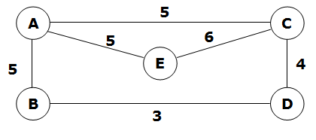
Total Weight of the Graph is :
5+4+3+5+5+6 =28

Two Algorithm From find minimal Spanning Tree :
PRIM’S ALGORITHM
KRUSKAL’S ALGORITHM

- PRIM’S ALGORITH :
Step 0: Begin with any vertex which you think would be suitable and add it to the tree from the given GRAPH.
Step 1: Select the edge with minimum weight.
Step 2: Select the adjacent vertex and select the minimum weighted edge using adjacent vertex. The selected adjacent vertex should be not form the circuit
Step 3: Repeat step 1 and step 2 untill all the vertices are getting covered.

Example:
Apply Prim’s Algorithm to the following graph and obtain minimum spanning tree.

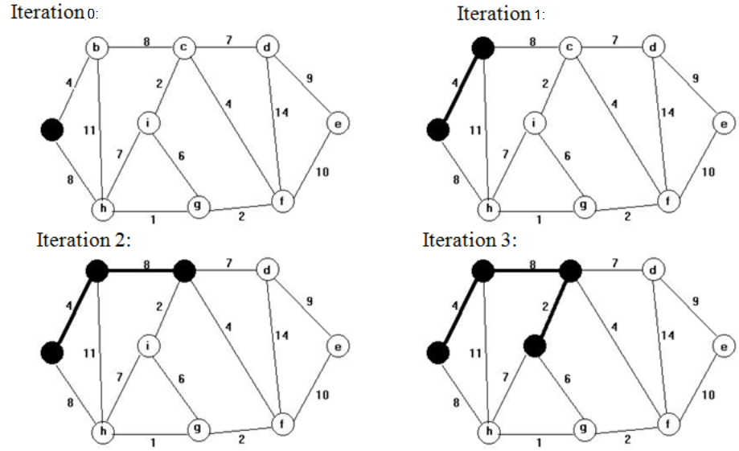
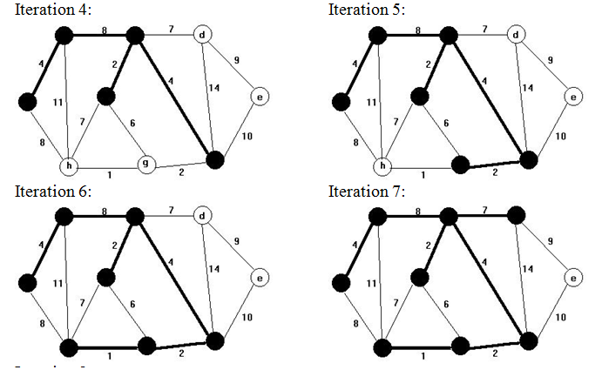

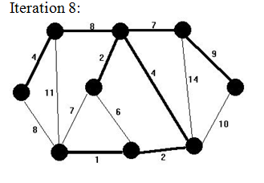
Here, the last iteration number 8 represents the optimal solution of the problem, given by the bold dark black lines, which gives us the minimum length of the path. And, the length would be calculated by adding the numbers written on optimal path. That is, 4 + 8 + 7 + 9 + 2 + 4 + 2 + 1 = 37 is the minimum length.

Example :
Using Prim’s Algorithm find the minimal Spanning Tree.
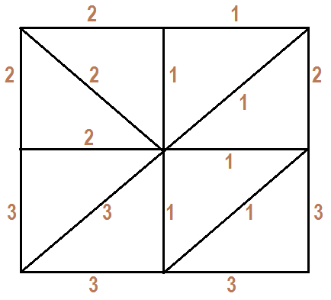
Ans: Total Weight = 14 for Spanning Tree.
Example : Using Prim’s Algorithm , Find the minimal Spanning Tree.
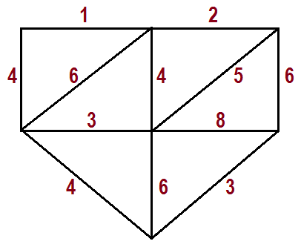
Ans : Total Weight = 17 for Spanning Tree.

Example: Applying Prim’s Algorithm to find the minimum Spanning Tree of the given Graph.
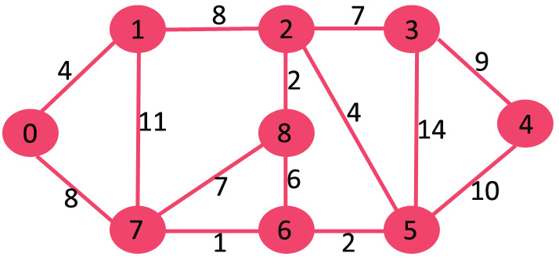
Solution :
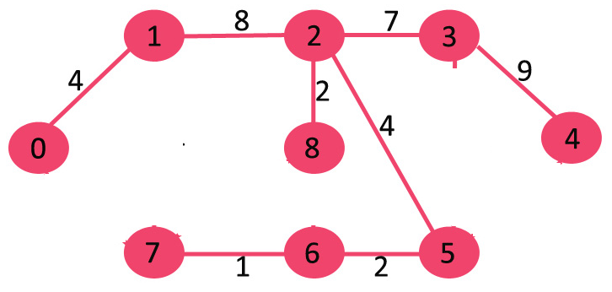
Ans: Total Weight = 37.
Example:
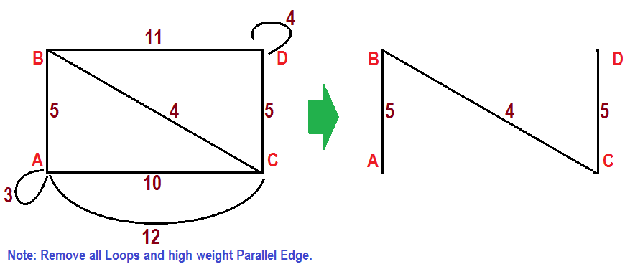
Ans: Total Weight = 14.

KRUSKAL’S ALGORITHM
Step 1: Create the Edge table
An Edge table will have name of all edges with their weight is ascending order.
So the no. of Column = No. of Edges
Example: Edge Table for Graph
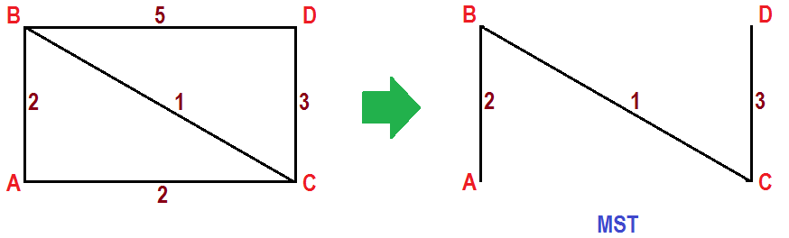
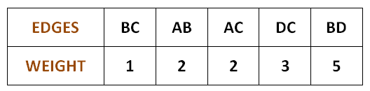
Note: Our Graph has 4 Vertices So, Our MST will have 3 Edges.
Step 2: To find the MST(Minimum Spaning Tree) We will start from the smallest weight edge and keep selecting edges that does not form any circuit with the previously selected edges.
Example: Apply Kruskal’s Algorithm to find a minimum spanning tree of a given graph.

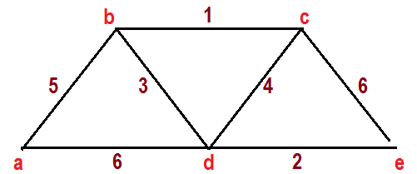
Edge Table is :
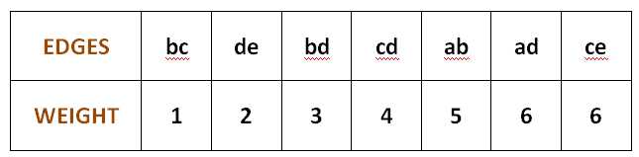
Spanning Tree is:
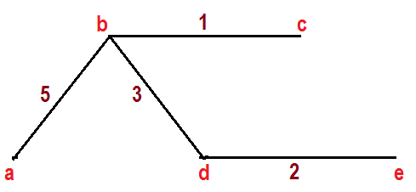
Ans: Total Weight = 11.

Example: Apply Kruskal’s Algorithm to find a minimum spanning tree of a given graph.
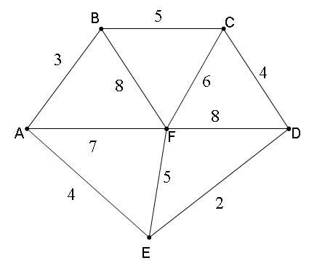
Solution:

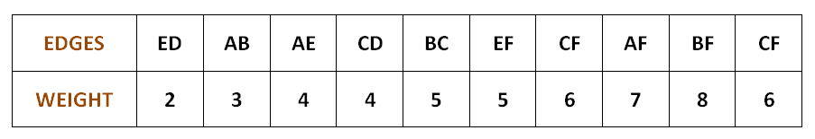

Solution is
ED 2 , AB 3 , CD 4 , AE 4 , EF 5,
with Total weight of tree equal to 18

Example: Apply Kruskal’s Algorithm to find a minimum spanning tree of a given graph.
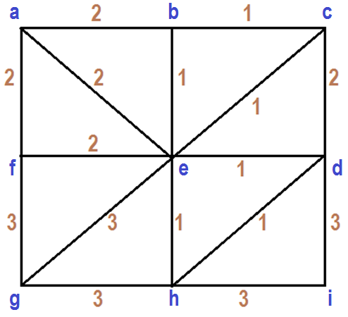

Ans: Total Weight = 14 for Spanning Tree.
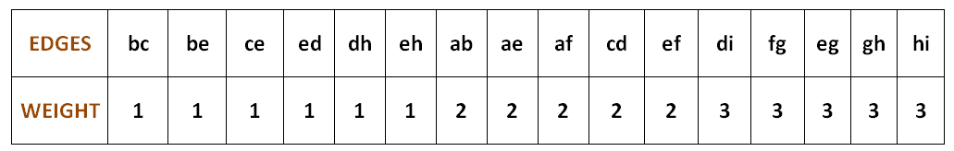

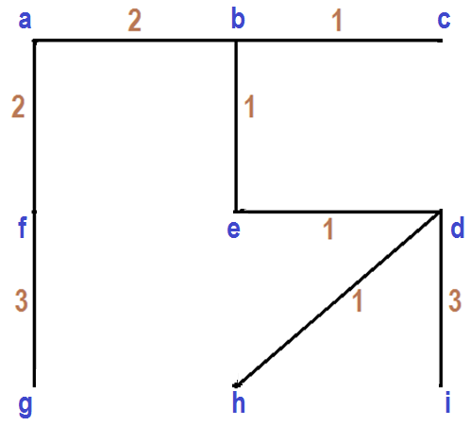

Example : Find the optimal path of the following minimal spanning tree by applying Kruskal's Algorithm.
Solution:
The optimal paths are drawn as bold lines representing the optimal paths of the spanning tree, which constitutes the minimum length of the shortest path, as shown below
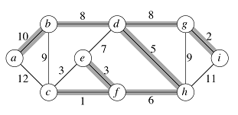
Similarity of Prim's Algorithm with Kruskal's Algorithm:
Prim's Algorithm is quite similar to Kruskal's with one big difference which is as follows:
The tree that we are growing or making it further ALWAYS stays connected. Whereas, in Kruskal's algorithm, we can add an edge to our growing tree that wasn't connected to the rest of it. But, here in Prim's Algorithm, we can't do it.

